**Personal Site**

### **Overview:**

* The purpose of this site is to show people or future clients that I am a web developer as well as a photographer and videographer.
* The site will be a static responsive site.
* Going to have 4 pages (Main, Bio, photos/videos, websites)

### **Goals:**

* My goal for this site is to attract people to view some of my creations and lead them to want to work with me. If they are looking for someone to take photos, make a video or even make a website for them. I'll be their guy.

### **Target Users:**

* My target users are people who need photos taken, website created, or even a video. I'll work with business owners or even people who just like these types of things being created for them out of fun. I’ll work with anyone.

User 1:

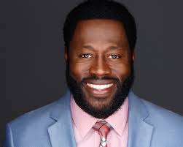

* **Fred** is a new business owner of a BBQ spot Downtown. He is looking for someone who can make a simple website that just has the menu and some information about his BBQ restaurant. Also he needs some help with promoting on social media, so he needs someone to take photos of his food and restaurant and make a short clip showing off his restaurant.

User 2:

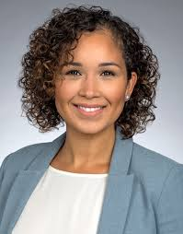

* **Angel** is a mother of 2. Her 12 year old daughter is having a birthday party. Angel needs a person to come to the party and take some pictures of the girls and family having a good time and also she wants a video shot for how the party went overall.

### **Content:**

* *Main Page:*
  + Preview of some of my pictures taken, brief preview of my videos created, sample of my websites created.
* *Bio Page*
  + Picture of me and a paragraph about me and a contact section.
* *Picture Page/videos* 
  + More showings of my photos and videos taken.
* *Website Page*
  + Displaying my web creations.

### **Similar Sites:**

* <http://www.kvonphotography.com/about>
* <https://atrapadream.com/>
* http://www.sbcwebs.com/